Assignment 5-
GitHub → Jenkins Build → WAR with Timestamp → Upload to S3 → Deploy to Tomcat
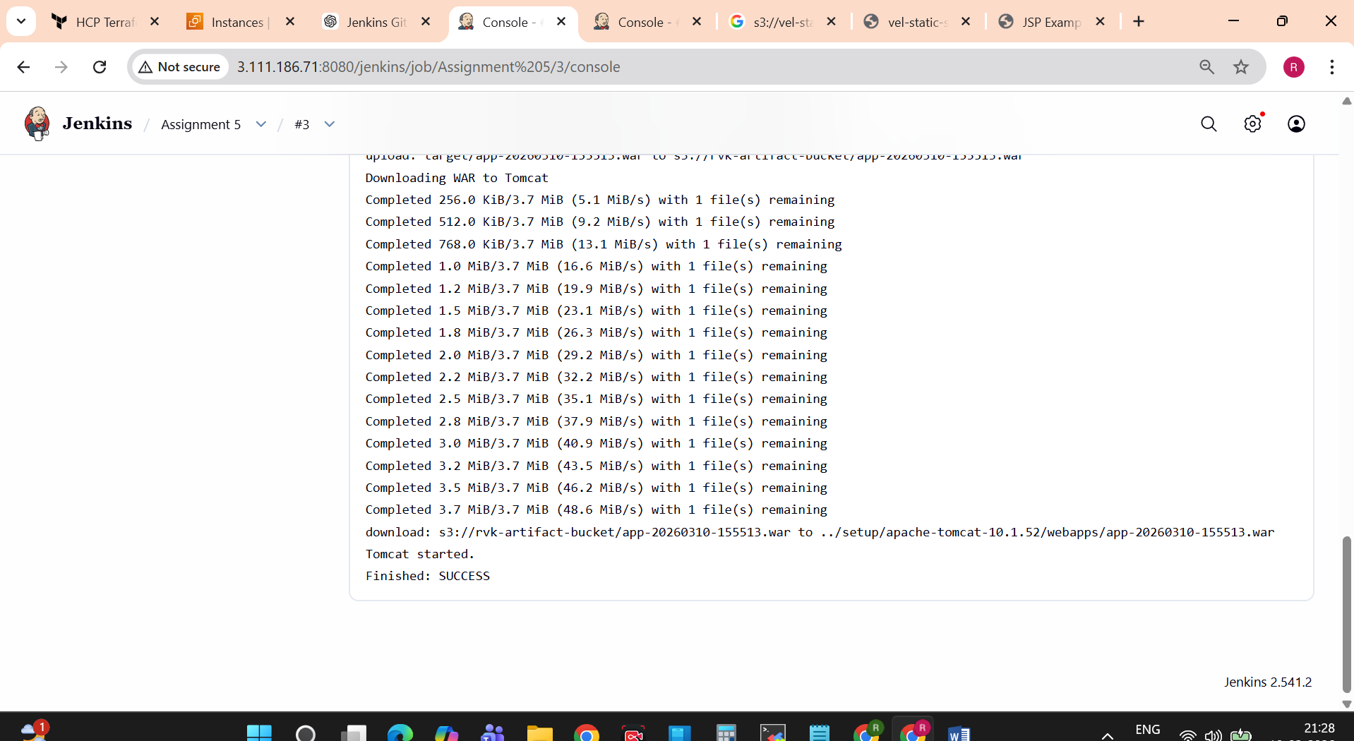

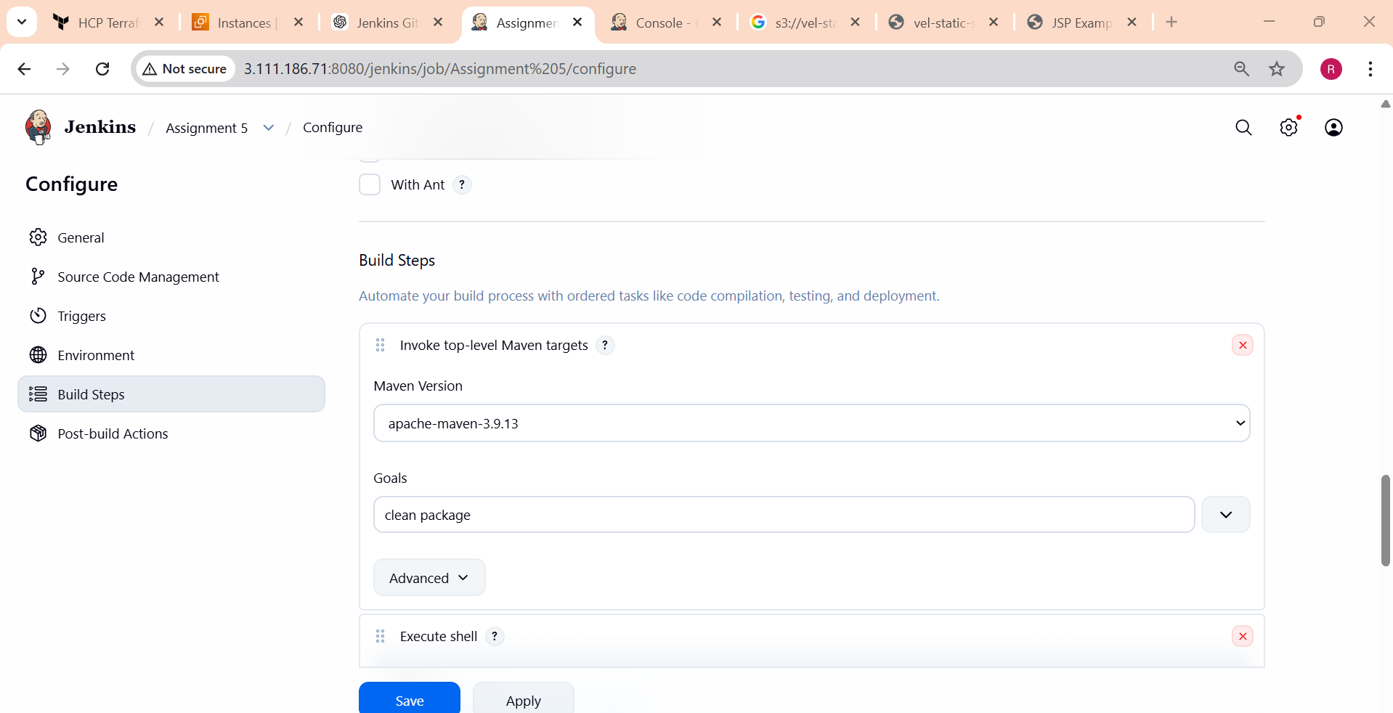
Execute Shell-
#!/bin/bash

echo "Creating timestamp"

TIMESTAMP=$(date +%Y%m%d-%H%M%S)

WAR_NAME=app-$TIMESTAMP.war

cp target/*.war target/$WAR_NAME

echo "Uploading WAR to S3"

aws s3 cp target/$WAR_NAME s3://rvk-artifact-bucket/

echo "Downloading WAR to Tomcat"

aws s3 cp s3://rvk-artifact-bucket/$WAR_NAME /mnt/setup/apache-tomcat-10.1.52/webapps

sh /mnt/setup/apache-tomcat-10.1.52/bin/startup.sh
Application accessible-
